Jane Armstrong
Student ID: 30155016
GitHub link: https://jane-armstrong-30155016.github.io/ITECH1502-Cybersecurity-Portfolio/
ITECH1502 Cybersecurity Portfolio
Eploring Vulnerability Scanning Tools on the TryHackMe Platform

Summary
For this assignment, I chose to explore vulnerability scanning, as I hope to pursue a career in cybersecurity and wanted practical experience using tools that would be used in this field.
The tools I used in this exercise were Nmap, Nikto and OpenVAS, using a virtual machine within the TryHackMe platform.
The main things I discovered were how these tools worked together to provide a detailed overview of potential security weaknesses, using fairly simple commands and actions. Nmap identified reachable services, while Nikto highlighted web-server configuration concerns. OpenVAS showed how findings can be grouped by severity and linked to known CVEs. ​Getting to view scan results and learn how to interpret them was interesting, and gave me insight into how small oversights in configuration such as allowing anonymous FTP login or a missing HttpOnly cookie attribute can expose a system to potential threats.
Overall, this practical experience developed my understanding of vulnerability scanning and strengthened my motivation to pursue a career in cybersecurity.

Introduction
Prior to this assignment, I had studied the theoretical importance of conducting vulnerability scanning in cybersecurity, but had no experience exploring or using any vulnerability scanning tools. I did not know what vulnerability scanning tools existed, what they looked like or how they could be used.
For this project, I chose to undertake the Vulnerability Scanning Tools exercise on TryHackMe. I selected this as my main areas of interest in cybersecurity are penetration testing, vulnerability assessment, ethical hacking and cybersecurity analysis. I therefore wanted to gain some practical experience with relevant tools. I saw this exercise as an opportunity to gain hands-on experience in the field I am most interested in.
Practical exercises like the one I have undertaken in this assignment are valuable as they connect theoretical knowledge gained in the unit to real applications, and give me an opportunity to explore tools that are used in actual cybersecurity roles. As I hope to work in this field in my career, it is helpful to understand what a cybersecurity professional might do when assessing systems for security weaknesses.

Challenge Description
The Vulnerability Scanning Tools exercise’s main challenge was to understand vulnerability scanning and why it is important in cybersecurity, how scans can help identify and assess security weaknesses before they can be exploited, as well as learning about CVEs (Common Vulnerabilities and Exposures) and CVSS (Common Vulnerability Scoring System).
The practical challenge was to use three different tools to scan for vulnerabilities in a system within a virtual machine environment. The tools used were Nmap, Nikto and OpenVAS. Nmap was used to discover hosts, open ports and running services on a network, to understand which network services were exposed. Nikto was used to scan a web server to identify potentially insecure configurations, outdated software and common web-server weaknesses. OpenVAS was used to assess host-level weaknesses and web application security issues, by running a scan on a target, examining the findings and interpreting the reported weaknesses.
I had no prior practical experience with vulnerability scanning tools prior to this exercise. To complete this challenge, I needed to learn new terminology such as CVEs and CVSS, as well as new linux commands. I had to learn how to read scan results and distinguish between results that might indicate a security weakness and those that did not pose a potential security problem.

Objectives
My main goal with the Vulnerability Scanning Tools exercise was to gain practical experience in penetration testing and vulnerability assessment. To achieve this goal, I wanted to learn to use tools used for scanning, which in the case of this exercise were Nmap, Nikto and OpenVAS. I also aimed to learn how scanning for vulnerabilities could identify potential security weaknesses, how to interpret scan results and how to understand which issues might need further investigation.

Methodology

Introduction and preparation
I decided to use the TryHackMe platform to focus on a challenge related to vulnerability scanning. I logged in to TryHackMe and searched the platform for “vulnerability scanning”. One of the results was the Vulnerability Scanning Tools room, which I selected and began. I opened a virtual environment by starting the Lab Machine provided in the TryHackMe room, which provided me with a temporary IP address. (Please note, as I had to restrart the virtual machine due to session expiring, IP address used in the exercises changed from 10.48.179.89 to 10.48.172.51)
Before using the scanning tools in the exercise, I learnt about the purpose of vulnerability scanning, its role in cybersecurity and some core terminology, such as misconfigurations, Common Vulnerabilities and Exposures (CVEs), and Common Vulnerability Scoring System (CVSS). I also learned about the different types of scanning tools: network scanners, web application scanners and host-based scanners. This gave me a good starting point for the practical exercises, as it gave context to what I was doing, rather than following instructions without understanding their purpose.

Nmap
The first step in using Nmap was to run a host discovery scan, using the command nmap -sn 10.48.179.89. This was to check whether the target host was online, without doing any further scanning for ports.
Next I ran a service and version detection scan, using the command nmap -sV 10.48.172.51. This was used to identify open ports and the services and versions running on them.
The third command I used was nmap -A 10.48.172.51, which ran an aggressive scan. This was used to provide more detailed information about service detection, operating system detection and script scanning and traceroute.

Nikto
The command nikto -h http://10.49.172.51:8080​ was used to scan a web server for potential security weaknesses and configuration issues. I examined the output of this scan, which identified a missing HttpOnly cookie attribute, potentially exposed server information, directory indexing and other web-server configuration issues.

OpenVAS
I accessed the Greenbone Security Assistant web dashboard in Firefox by entering the URL http://127.0.0.1:9392. At the login page I entered the default credentials to access the site.
My first task was to create a new target, as a target needs to be defined before any scan can be run on OpenVAS. To do this I clicked on Configuration > Targets, clicked the (+) icon, and entered the target name SecondTarget and the IP 10.49.172.51.
I then created a scanning task and attempted to run it, by clicking Scans > Tasks, the (+) icon, and selecting New Task. I entered the task name SecondTask and selected the target I added earlier. I then clicked Run to begin the scan.
As TryHackMe advised the scan could not be completed in the lab environment, as it required an active internet connection and takes 20 to 25 minutes to run. There was therefore a report from a previous scan provided by TryHackMe to view. I selected the report saved under MyTarget > Scans > Reports, and examined the results.

Best Practices
The last task in the exercise was to learn about best practices in vulnerability scanning, which included beginning with non-intrusive scans to avoid disrupting the target system, using the right tool for the job, verifying any high-severity results manually to avoid false positives, staying updated on new issues, comparing saved results regularly and scheduling scans during low-traffic hours.

Results

Nmap

Host discovery — nmap -sn
The results of the nmap -sn scan confirmed that the target host was online and responding to probes.

Service and version detection — nmap -sV
The nmap -sV scan showed that five ports on the target system were open (Figure 1). The output also showed the version of each of the services running on those ports. The open ports were 21 (FTP), 22 (SSH), 80 (HTTP), 5901 (VNC) and 8080 (HTTP). While the open ports did not in themselves indicate a security vulnerability, they provided information about possible avenues of access which may be a concern. For example, the open FTP port could pose a security risk if attackers were able to log in and access files via this port, which could expose sensitive information, depending on what the files contained. Additionally, the information obtained about the service versions could allow attackers to exploit known flaws in those versions.
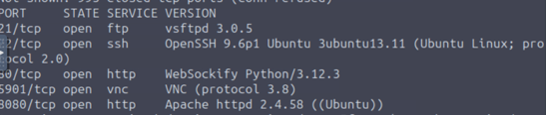
Figure 1: screenshot showing the five open ports on the target system.

Aggressive scan — nmap -A
The nmap -A scan showed additional information about the target system, including SSH keys, HTTP banner data, OS detection, and runs scripts to get deeper insight into each service (Figure 2).
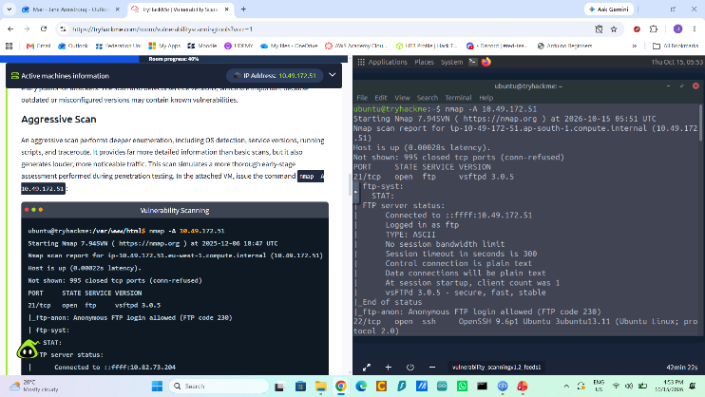
Figure 2: Screenshot showing the first section of output from the Nmap aggressive scan, showing anonymous FTP login access permitted.
The areas of greatest concern were the fact that anonymous FTP access was permitted, service banners revealing software versions, and the missing PHP HttpOnly flag potentially allowing a session cookie to be accessed by on the client side. Further investigation is needed to confirm if any of these potential security concerns pose actual threats.

Nikto
This scan was performed on the open 8080 port to check for any security weaknesses. Several potential security weaknesses and information-disclosure risks were identified. (Figure 3). These included detecting the server version as Apache HTTP Server 2.4.58 on Ubuntu, which attackers could use to look up known vulnerabilities for that version, the missing HttpOnly flag, an exposed PHP Info Page which can reveal information about the system, modules, configuration and environment variables, and exposed directory indexing which can reveal files that shouldn’t be visible to the public.
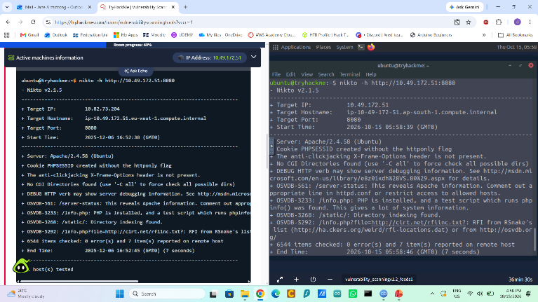
Figure 3: The output of the Nikto scan, showing potential security findings of the web application on port 8080.

OpenVAS
The OpenVAS report showed an overall severity score of 6.4 (Medium), as well as identifying several individual potential security weakness (Figure 4). The areas of greatest interest were the anonymous FTP login reporting, which had a severity rating of 6.4 (Medium) and the phpinfo() output reporting which had a rating of 5.3 (Medium). Other findings included a missing HttpOnly cookie attribute, unencrypted FTP login and TCP timestamp information disclosure, which was rated 2.6 (Low). Reviewing these results helped me understand how vulnerability scanners classify security findings by severity, allowing security professionals to identify which issues may require further investigation and remediation.
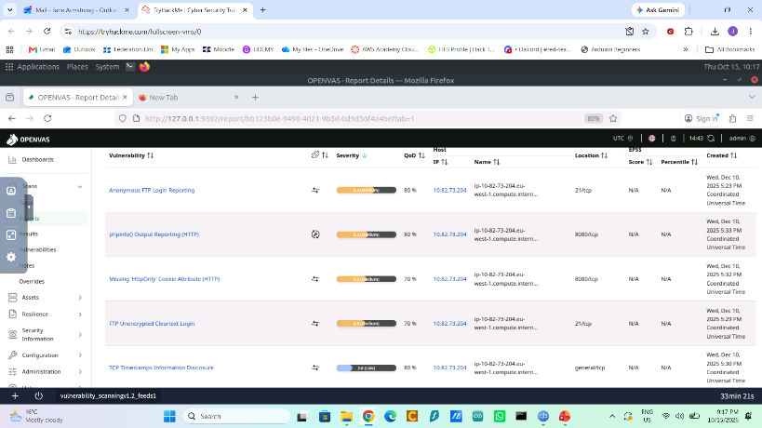
Figure 4: Results page from OpenVAS scan report.

Reflection
In this exercise I gained a practical understanding of vulnerability scanning and saw how a few relatively simple commands can reveal a surprising amount of information about a system. I also learned that seemingly minor security weaknesses can create significant risks if they aren't addressed.
The practical experience I gained in this assignment was very valuable, as I am someone who likes putting theory into practice, and want to have a career in this field. Using Nmap, Nikto and OpenVAS helped me understand how vulnerability scanning works in practice, rather than just learning about it theoretically. I gained experience interpreting scan results and identifying potential security concerns, and got an insight into how cybersecurity works in real life.
This experience has increased my motivation to pursue cybersecurity, particularly in the field of penetration testing or cybersecurity analysis. I found using real commands and tools interesting and enjoyable, and it gave me a better understanding of how cybersecurity works in action.
If I was to undertake this exercise again, I would try to complete the exercises in one active session to reduce inconsistencies, such as the target IP address changing between scans. I would also like to use a fully functioning environment so I could run complete scans, particularly with OpenVAS.
In the future I would like to complete more practical exercises to explore the capabilities of Nmap, Nikto and OpenVAS in greater depth, improve my ability to interpret findings, and develop my skills further for a future career in cybersecurity.

